* 1. Purpose
     + To track the mileage, you drive in a vehicle.
  2. Audience
     + Anyone who wants to track their mileage.
  3. Data sources
     + External API on a NodeJS server with user inputted data.
  4. Initial Module list
     + User Login, User Registration, Mileage Input, and Filtering.
  5. Wireframes for each view of your application

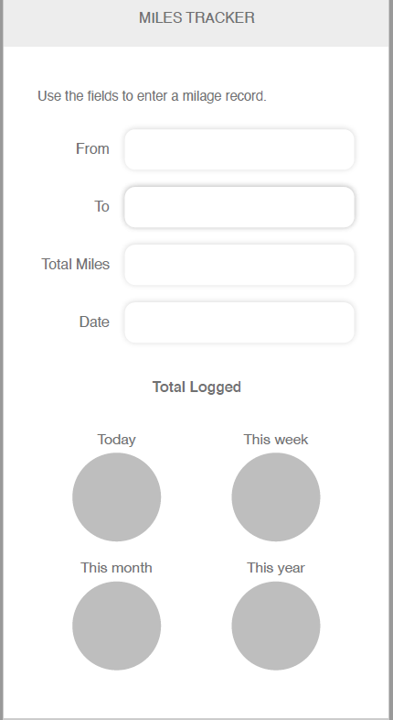 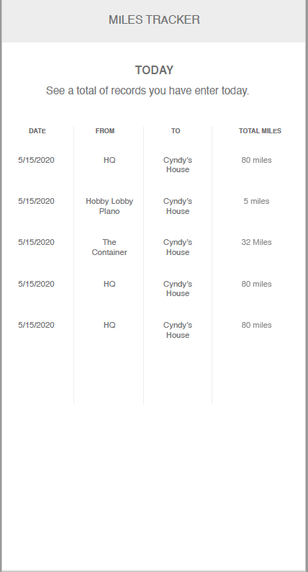

* 1. Colors/Typography/specific Element styling
     + Navy Blue background with white text
     + Lato Light Font for Alpha text
     + Playfair Display Font for numeric text
  2. Schedule
     + Week 1: UI Screens
     + Week 2: Login and registration working.
     + Week 3: Mileage input and filtering working.
     + Week 4: Testing and bug fixes.